Climate Conversations: What is age-appropriate?
Below are some suggested nature connection, climate wellbeing, systems, psychology and justice activities and ways of talking, for children of different ages.
Every child is different – the best approach is to meet the child ‘where they are at’. Students with a history of trauma or special educational needs may need a more tailored approach.
Age in UK school system | Suggested activities | Suggested scripts/ language for ‘climate truth’ - to adapt your own voice
Pre school and reception  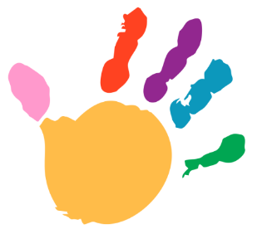 | Focus on daily activities (e.g. walk instead of the car, litter pick, recycling bins, using both sides of the paper).  Normalising sustainability in family and school life, talking about health benefits. Normalising care for all animals and the environment (e.g. not killing bugs).  Success stories of animals in their ecosystem (e.g. reintroduction of wolves to Yellowstone Park & impact on ecosystem)  Outdoor learning & biodiversity – e.g. insect counting, pond dipping. Discussing threats to ecosystems and what can be done to protect (e.g. don’t use pesticides because it can kill bees)  Art with nature (e.g. leaf rubbing, flower crowns).  Nature for sensory play and relaxation e.g. walks, tree climbing, cloud spotting, sand play, water play. Encourage children to notice how they feel. |  “We need to care for the planet so the weather stays calmer. Big storms, very hot summers, or lots of rain makes life harder.  Driving cars and planes and making new things makes gases which are like a blanket for the earth.  We’re all working to make changes to slow down the earth getting hotter, as this affects the weather. This is actually going to make us healthier, too”.
Key stage 1  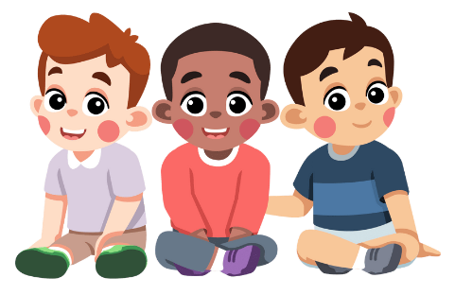 | As above, and:  Involvement in and visits to sustainability and biodiversity solutions (e.g. solar panels, wind turbines, EVs, rewilding projects, regenerative agriculture farms).  Stories and case studies of social change and environmental solutions (e.g. ozone layer).  Learning about young and old activists around the world. Ask - how would you feel if you lived there?  Project learning to affect change in school & community (e.g. ‘stop engine idling’ campaign with parents).  Learning self-regulation tools including meditation and breathing techniques. | “Higher temperatures from global warming change the weather and make it more intense. When it’s very bad in some places, there can be floods, wildfire and damage to food crops. The animals and their home (ecosystem) suffers too.  When there’s damage to our crops or buildings this costs more money for everybody. So, weather and living conditions are going to get harder. This looks different around the world, some countries are very badly affected, particularly in the global south.  We will prepare for this while also making changes to slow down warming. This includes stopping activities that make the greenhouse gases that heat the world up and making more sustainable choices. Change is hard at first, but it will lead to a healthier way of living. We can do it together..”
Key stage 2  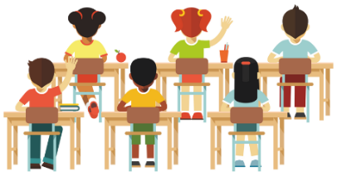 | As above, and:  Stories and case studies of social change and climate solutions (e.g. smoking ban, end of apartheid, U.S. civil rights movement, recent rise in solar panels and drop in cost).  Group work writing / imagining ‘Thrutopian’ stories which acknowledge challenges to come and lay out a realistic way through.  Learning about young activists around the world and the societal, cultural and legal challenges they face. e.g. prison sentences, online hate.  Project learning to affect change in school & community  (e.g. changing canteen offering/ contact council about ‘no mow may’.)  Offer membership of an eco-council.  Group work role play – imagine a scenario (e.g. flight grounded due to climate protest /ULEZ expansion) & what everyone is thinking.  Learning about sitting with feelings e.g. ‘R.A.I.N. meditation (recognise, allow, inquire, nurture, Tara Brach) | It's true that if we don’t change our greenhouse gas emissions, the earth’s weather will get more intense, making life much harder for everyone.  Some people will be affected more than others, which isn’t fair, particularly if their country been responsible for much greenhouse gas emissions in the past. Many people across the world may lose their homes, way of living or even their lives.  We will prepare for the impacts here and handle whatever comes our way, together. It’s also right to keep on cutting greenhouse gas emissions as much as we can.  The less greenhouse gas we release, the less warming there will be, so it’s always worth cutting the gas emissions and making sustainable choices. The sooner we do this, the more effective it will be.  Although not everyone can afford to make changes all at once, there are lots of are lots of people working on making sustainable changes. The more people that do this, the easier and cheaper it becomes for everyone to make healthy and sustainable changes. “
Key stage 3 | As above, and:  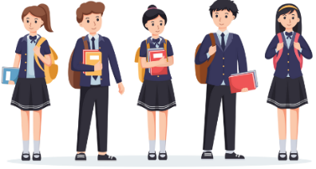  Stories and case studies of social change and climate solutions (e.g. A.I. food supply chain efficiency, digital democracy in Taiwan).  Engagement in protest and petitions (e.g. big soda out of sport).  Student led project learning to affect change in wider community and online.  Carbon literacy – to consider supply chains, transport, packaging and manufacturing (e.g. ‘How bad are bananas?’ game).  Learning about UN sustainable development goals and internal development goals.  Fake news and social media – fact checking and misinformation spotting. highlighting the difference between fact and opinion. Greenwashing spotting.  Learning about ‘thinking traps’ for climate anxiety.  Learning about the indigenous critique and climate justice. How might these populations feel? | “Global warming speeds up once it gets going. For example, when glaciers melt, they reflect less sunlight back, so the sun’s heat stays around to warm the earth further. so that’s why so many people are working hard and campaigning to make sustainable changes… it is urgent.  As things get harder around the world, it affects us all, as our food supply chains and businesses are all connected. Some people will have to move country, so there might be more work to do to keep people safe.  The most affected countries and areas are often the least responsible for historical emissions, which isn’t fair. Many people across the world may lose their homes, way of living or even their lives. Often it is the poorer or minority communities that are more vulnerable and hardest hit. e.g. if you can’t afford air con.  Making the changes necessary to protect ourselves from impacts like heatwaves and to make sustainable changes will cost money at first and it will be hard for a lot of people. We don’t know exactly how things are going to play out but we are going to work together to make the changes necessary.  This is actually a healthier way of living, and many people are now realising that they don’t need unnecessary stuff”
Key stage 4 and above  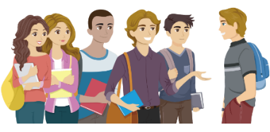 | As above, and:  Student led protest and petitions.  Carbon literacy - The Financial Times climate game – simulation of global systems interacting.  Learning about planetary boundaries and feedback mechanisms.  Fake news and social media – fact checking and misinformation spotting (e.g. comparing different ‘news’ outlets reporting on the same event for reliability and accuracy).  Debate and critical reasoning – aim is to give children a voice and get them to think for themselves. e.g. debate:  - What would you give up to save a stranger’s life?  - Who should pay for flood damage?  - Does money make you happy?  Learning about psychological defence mechanisms for climate engagement. Role playing different points of view.  Learning about wellbeing and local economies, donut economics, responsive democracy.  Learning about the links between climate justice and colonial histories/ racial oppressions.  Learning about the drawbacks and barriers to some ‘green technologies’ e.g. EV minerals mining, A.I. energy use. | “This is a big shift in how we have been living. Greenhouse gases and a lack of regard for the environment have meant that weather conditions will make it too hard to live in many places.  The earth’s feedback mechanisms (e.g. warmer oceans hold less oxygen, burnt forests do not sequester carbon) mean that there are ‘tipping points’ or ‘planetary boundaries’ that we must stay within. It is really hard for scientists to measure and know how close we are to these. What we do know is that the more greenhouse gas emissions we reduce now, the more effective those changes will be. We need everyone to be working together.  Different populations and areas are impacted differently, which isn’t fair, especially as the people most impacted are often those who emit the least greenhouse gases. Often it is the poorer or minority communities that are more vulnerable and hardest hit. In some countries, this is related to the history of colonialism, where practices of taking resources from the land and disrupting indigenous peoples have damaged the ecosystem.  As all our systems are connected, this will impact everyone, through supply chain disruption, migration and other economic pressures. We’ve all got some tough decisions ahead as we balance the need to adapt and prepare for climate impacts, while doing everything we can to limit global warming.  Not everyone can afford to make changes straight away, but there are lots of people taking steps in the right direction, which brings the cost down for others. We need to support and accelerate this transition, so that we stay within the safe planetary boundaries. A lot of people think that living more simply and sustainably is actually a healthier and happier way of living. We are realising that unnecessary consumption doesn’t make us happy.”

