Biodiversity Conversations: What is age-appropriate?
Below are some suggested pointers for nature connection, biodiversity and species extinction activities and ways of talking, for children of different ages.
Every child is different – the best approach is to meet the child ‘where they are at’. Students with a history of trauma or special educational needs may need a more tailored approach.
Age in UK school system | Suggested activities | Suggested scripts/ language for ‘biodiversity crisis truth’ - to adapt your own voice
Pre school and reception  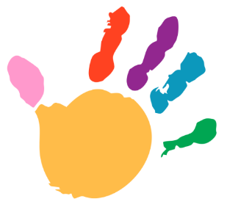 | Focus on daily activities (e.g. spotting the trees and animals in your environment).  Normalising care for all animals and the environment (e.g. not killing bugs). Why animals die.  Success stories of animals in their ecosystem (e.g. reintroduction of wolves to Yellowstone Park & impact on ecosystem)  Outdoor learning & biodiversity – e.g. insect counting, pond dipping. Discussing threats to ecosystems and what can be done to protect (e.g. don’t use pesticides because it can kill bees)  Art with nature (e.g. leaf rubbing, flower crowns).  Nature for sensory play and relaxation e.g. walks, tree climbing, cloud spotting, sand play, water play. Encourage children to notice how they feel. |  “We need to care for the planet, plants, animals and fungi.  Some of the things people do, like cutting down trees, or pollution from planes is harming nature.  We’re all working to make changes to help life on earth. We can help by being gentle with nature, planting flowers, and picking up litter. That helps animals and makes us feel calm and proud. This is actually going to make us healthier, too”.
Key stage 1  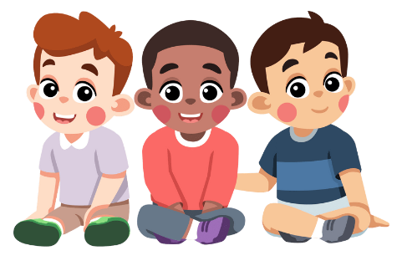 | As above, and:  Involvement in and visits to conservation projects, biodiversity solutions (e.g. rewilding projects, regenerative agriculture farms).  Stories and case studies of endangered species and those who lead in conservation efforts (not just charismatic megafauna). Sharing successes  Project learning to affect change in school & community (e.g. low bang fireworks).  Learning self-regulation tools including meditation and breathing techniques. | “Higher temperatures from global warming change the weather and make it more intense.  When it’s very bad in some places, there can be floods, wildfire and storms and the sea gets warmer. The animals and their homes (ecosystem) suffer too.  Sometimes humans can kill animals for food or their fur/ horns or when they use the land the animals live on.  When animals and plants aren’t healthy, it makes life harder for other animals and for people  There are lots of groups working around the world to help protect and save the animals  We can do small things like planting flowers and stopping litter and pollution.. When many people help, it gets easier for animals to live.
Key stage 2  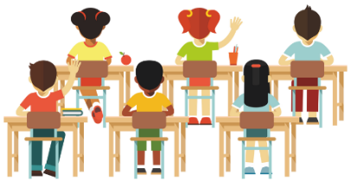 | As above, and:  Emphasis on ecosystems and the interconnections between living things. What happens when populations rise and fall. Ecosystem simulation games then going. Biodiversity mapping in e.g. pond.  Stories and case studies of species reintroduction and challenges that people may have faced along the way.  Animal personification stories – writing, drawing or acting from animal’s perspective.  Project learning to affect change in school & community  (e.g. contact council about ‘no mow may’.)  Biodiversity stripes. Introduce concept of extinction. And exploration of the feelings that arise. Learning about sitting with feelings e.g. ‘R.A.I.N. meditation (recognise, allow, inquire, nurture, Tara Brach) | “Animal habitats (where they live) are impacted by climate change. E.g. warmer seas means there’s not enough oxygen for sea life to breathe. A wildfire from too much dry and hot weather will also harm the home of animals that live there.  As well as climate change, Human activities like building, pollution and some farming practices have reduced where animals and plants can live People have to make money to live and sometimes they do this by cutting down trees, or killing animals for food, pets, blubber, for their fur, or horns. Some places and people are affected more than others; losing species changes food, medicines and cultures  Extinction means that there are no more of that species left. It’s a very sad thing to happen. Endangered means that the animal species is ‘in danger’ of extinction because their numbers are so low. There are projects underway to freeze the DNA of animals, so they may come back from extinction, but this is a last resort. First, we are trying to stop animal numbers from dropping.  There are lots of other people and groups and laws trying to protect the animals. We need urgent action. Learning the science and speaking up for fair solutions help
Key stage 3 | As above, and:  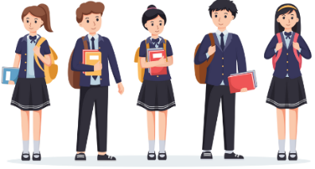  Understanding the laws, culture powers and factors that help and hinder conservation efforts. Stories and case studies that include an element of social complexity .  Debate – e.g. should more housing be built on grey belt?  Understanding ecosystem collapse. Looking at graphs of species decline. Discussion about why humans need ecosystems.  Engagement in national protest and petitions (e.g.. banning glyphosate use).  Student led project learning to affect change in wider community and online. E.g.. Opposing runway expansion.  Learning about UN sustainable development goals and internal conservation efforts.  Learning about indigenous perspectives of nature connection and wisdom traditions of interdependence. How might these populations feel when they see western disregard for nature? | “Global warming speeds up once it gets going, weather patterns will get more and more intense.  As things get harder around the world, it affects all living things as our food supply chains and businesses are all connected. Countries and communities that have done the least to cause these problems are often hardest hit  When species die out there is a risk of ecosystem collapse, which means that lots of species die - which is a threat to humans as well as animals.  It’s very hard for scientists to calculate but there are probably now hundreds of species dying out per day. This is a mass extinction.  More and more people are realising that living in harmony with the earth is not only essential for the survival of life of earth, but it is a healthier and happier way of living. Many people are now realising that they don’t need unnecessary stuff”
Key stage 4 and above  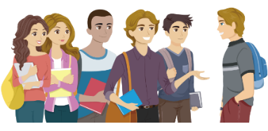 | As above, and:  Learning about planetary boundaries and feedback mechanisms.  Debate and critical reasoning – aim is to give children a voice and get them to think for themselves. e.g. debate:  - What would you give up to save a species?  - Who should pay for conservation efforts?  Learning about wellbeing economies, donut economics,. Historical exploitation and colonial practices link to current losses  Learning about the trade offs with climate mitigation efforts and biodiversity protection efforts (e.g. windfarms harming local wildlife) | “There have been other mass extinctions in the past, the last one happened millions of years ago when a meteor hit the earth, causing the earth to be covered in gas and dust, and cool down so much that the dinosaurs died out.  This current mass extinction (the 6th), is human made, so is in our power to change.  Large-scale biodiversity loss threatens food security, economies and cultural heritage; ecological tipping points are possible and uncertain.  More and more people are making changes to the way we live and do business, but we need to get most people on board with this, including governments and big business. Solutions work better when they are fair and respect local knowledge.  How we shop, vote and use our time all makes a difference as we influence other people.

